*Insurance Premium Predictor*

***Wireframe Documentation***

# Homepage

The Homepage of our Insurance Premium Predictor will ask for User Inputs by either entering numerical data or choosing from given options.

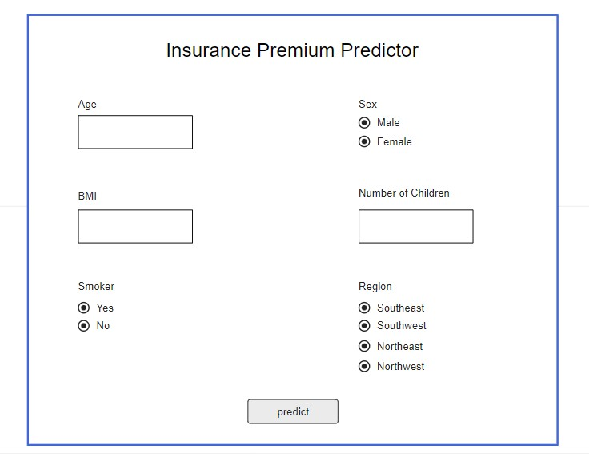

# Results page

Based on User’s input, our Insurance Premium Predictor will estimate results to User on Results page. A sample view of Results page is below:

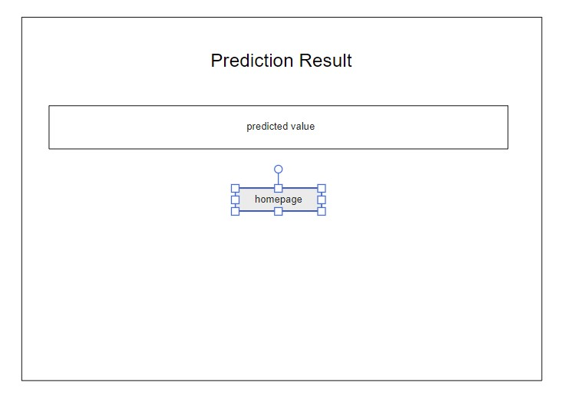

# Invalid Input

In case User inputs are invalid, a message is displayed indicating the User entered invalid Input and a button to redirect to the homepage is provided.

A sample view of Invalid Input page is shown below:

